HistoryPin Instructions

HistoryPin is a new Web tool that allows groups to co-curate a collection of historical resources on some identified topic. We will be using HistoryPin in Stockholm to co-curate a historical collection on Stockholm museums. Before getting started, students will need to do two things:

Preliminary Steps

1) sign up for a building to research for our practice NC State Main Campus Collection, and a museum to visit and research for our final Helsinki Museum Collection, http://tinyurl.com/hmyceob
2) sign up for a HistoryPin account at http://www.historypin.org
Note, you must join HistoryPin and set up an account before you can add pins to collections. Please add your photo to your account, as this displays with your pins for a better visual look.

Research Steps

Before pinning a site to a collection, you will need to spend some time researching the sites you’ve selected above (i.e., NC State building, Stockholm museum). You will need at least three pieces of information to continue to the pinning stage:
- When pinning, you will be asked to upload a photo, so you will need a photo of your site. Please take original photographs or find only copyright-free photos in the creative commons that can be reused for non-commercial purposes.
- You will need a paragraph of text about your site. The paragraph can include personal anecdotes about what you experienced or saw at a site, a description about what others will be able to see at a site, and/or some historical information in keeping with the purpose of the HistoryPin tool to archive historical collections. For your museum pin in Stockholm, please do tell us what you experienced/liked/disliked when you visited, what exhibits/content one can see at that site, and give a bit of historical background on the museum too (e.g., years in operation, mission, benefactors, etc.). Please type only original text, don’t copy and paste from another site. It is okay to paraphrase, or if you want to use text from another site, use quotation marks and reference your sources. Here is a sample paragraph from a pin in the NC State Main Campus collection:
Opened in 1889, the Romanesque-style Main Building was the first building constructed on campus. The building was constructed on the former Eason Lee farm and three sets of unidentified bones had to be removed during construction, leading to some tales about the building being haunted. The source of a fire that started in the building just prior to opening in 1889 was never identified, but led to several conspiracy theories, including ghosts from disturbed gravesites, sharecroppers losing their farm land to the new campus, and students from UNC-Chapel Hill unhappy that the state legislature appropriated land-grant funds to create A&M college. The building was constructed with 1.2 million bricks provided by prisoners at the nearby state penitentiary. Designed as a multi-functional space to serve as the entire college, the original building contained labs, cooking and dining facilities, a gymnasium, faculty offices, classrooms, a library, and dormitory accommodations on the second and third floors for 72 students. Raleigh's City Council designated the building a historic site. The building was not known as Holladay Hall until 1915 when it was named in honor of NC State's first president (1889-1899), Alexander Quarles Holladay. Holladay was a graduate of the Universities of Virginia and Berlin, who fought in the Civil War under General Bragg.
- You will need the physical address of the site you are pinning (e.g., 120 Swede Street, Stockholm), as this will add your pin to the right place on the collection map.

Pinning Steps

With your research information in hand, you are ready to pin your site to a collection. Two collections have already been created for you for this activity. You will not create your own collection; rather you will contribute your pins to our group-edited collections.

Log-into you HistoryPin account, and first, open the collection you want to pin to:
NC State Main Campus Collection, http://tinyurl.com/zaswpzw
Stockholm Museum Collection, http://tinyurl.com/l5z63km

Once you are in a specific collection, click the icon to “Pin Something” to that collection. If you don’t see this option, check to make sure you are logged into your account. Your HistoryPin user name should be showing in the upper right-hand corner if you are logged in. | 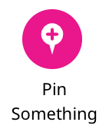

The first thing HistoryPin will ask you to do is load a photo, video, or text of the site you are pinning. You are limited to one photo/video. We suggest an external photo of the site, or a particularly telling photo from the interior. You can also upload a more comprehensive video. Please do not load text at this step--load visual media only (photo/video). | 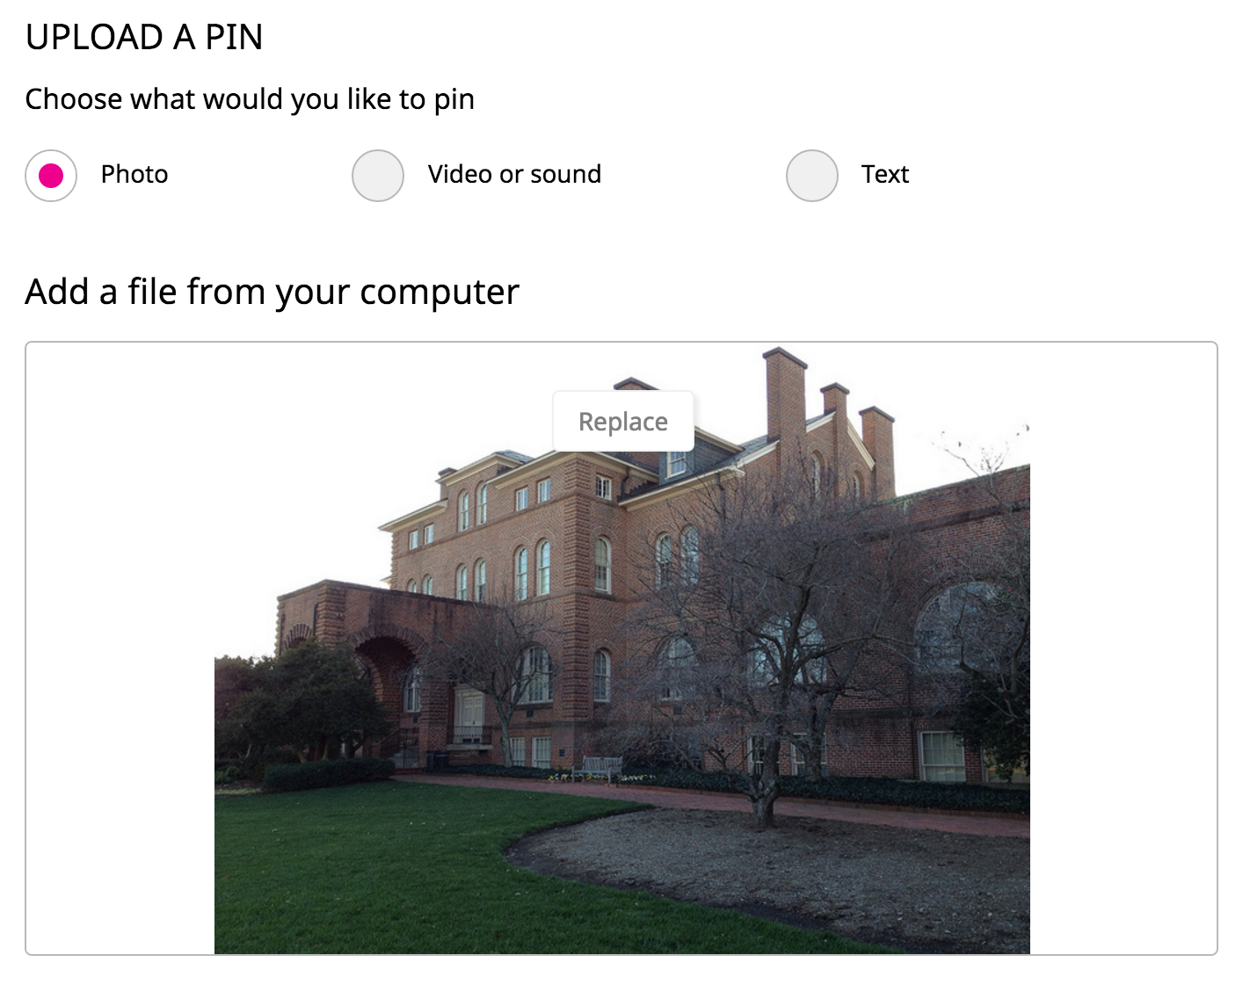
The next step is to load a title and a description of your site. This is where you put your research text. Bug Alert: If you copy and paste text into the “description” box, go back up and look at the photo/video you loaded. I ran into an issue of when I pasted text into the description box, it was over-writing my photo. I had to re-type my text into the description box, or else it over-wrote my photo. Make sure you don’t run into the same issue. If you do, just “cancel” your pin at the bottom and start over. | 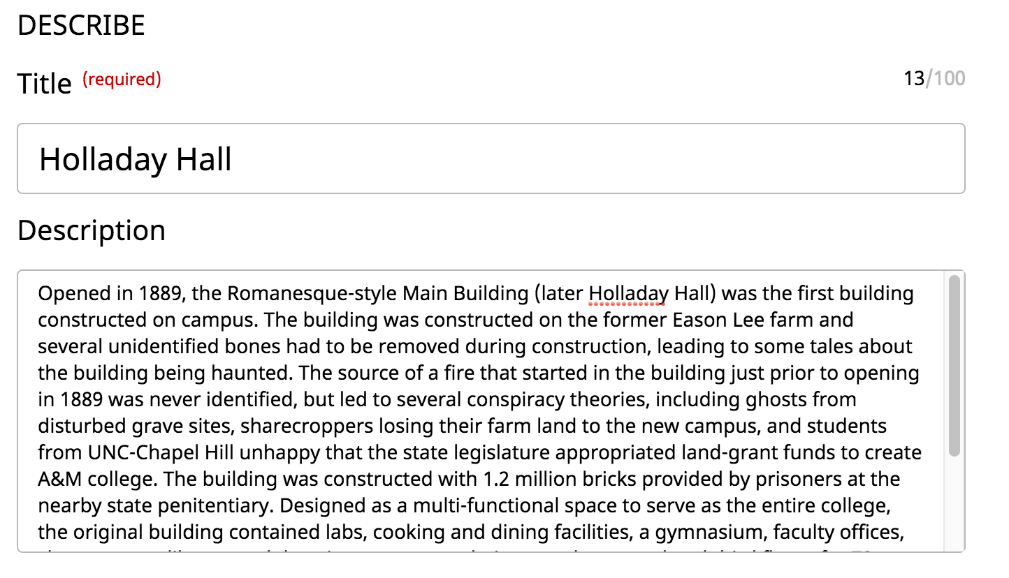
HistoryPin now asks how you want to license your pin. I suggest leaving this at the default setting of “ShareAlike.”
Next, please type in the exact address of the building or museum you are pinning, so the map will display where your site is appropriately. | 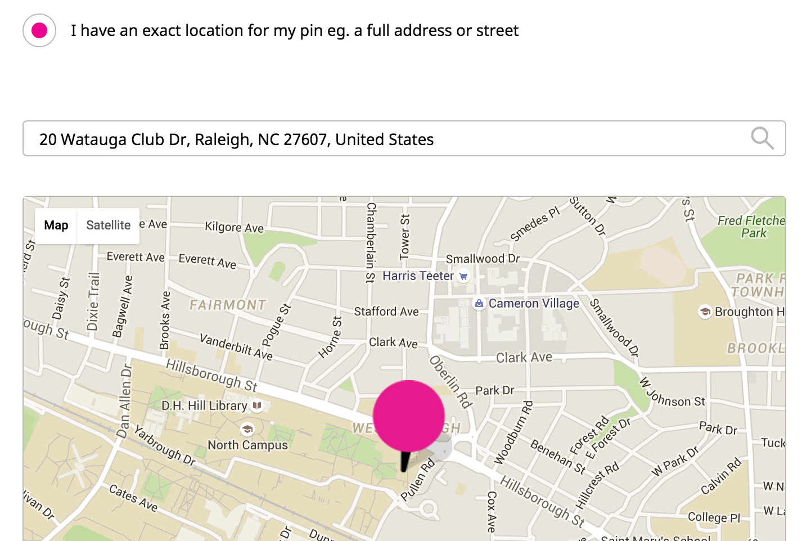
Enter a few tags to describe what your pin is about. For a campus building, you can just enter a few tags like “academic building” and “university.” For a museum in Stockholm, enter “museum” and other tags related to the content material in that museum. | 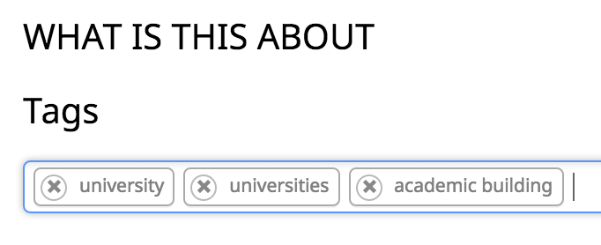
Finally, check to make sure you are pinning this pin to the right collection. If you started out in the right collection at the beginning of these instructions, you should be in the right place here. | 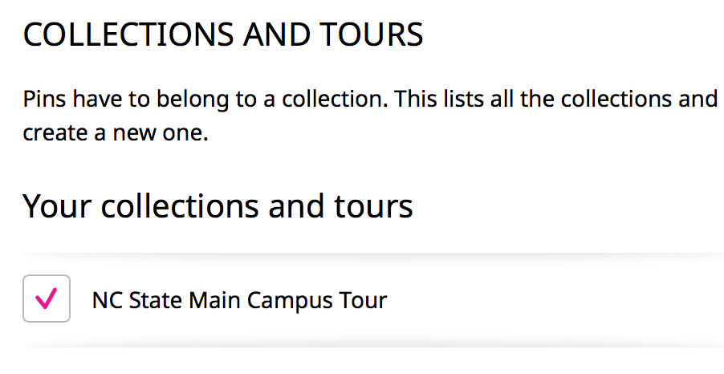
At the bottom of the pin screen, click “Save” to pin your item to the collection. If you don’t immediately see your saved pin among the items in the collection, find your actual pin on the map and click it. That action seems to display the title/text for a given pin as shown at right. | 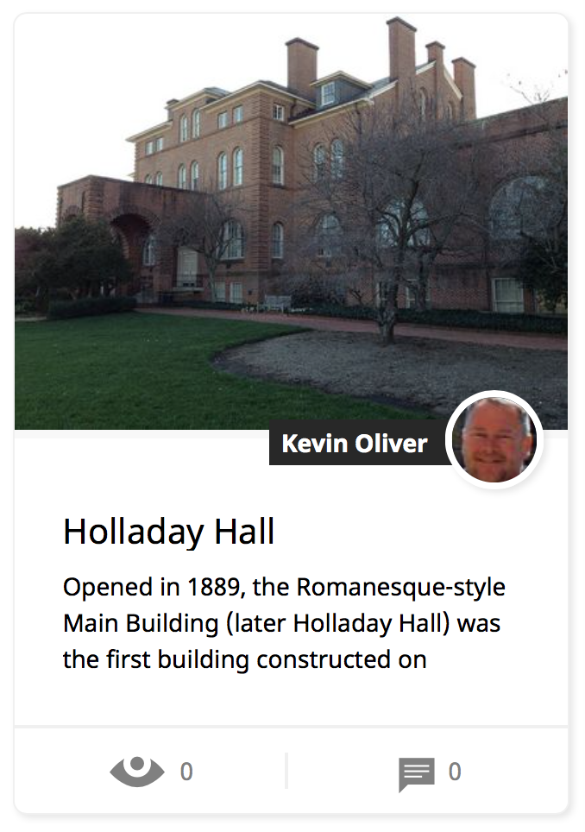

Sharing to Your Weebly Portfolio

The last step in this process is to share/show your pins on your Weebly portfolio page. In HistoryPin, click to open your pin page. Click the icon on the right to “Share” your pin.

Next, copy the second set of embed code that starts with <iframe width=

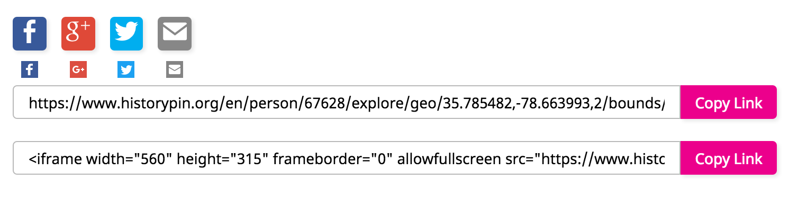

Now, go to your Weebly portfolio page, and under Cultural Collections Project 2, paste the embed code you just copied into one of the “embed code” blocks that we already loaded onto your portfolio pages. If successful, a copy of your HistoryPin pin should now display on your portfolio page. Don’t forget to click “Publish” in Weebly to lock-in/save your changes.

