Instructions for Cultural Collections Project 2: MyHistro

Step One: Register. Sign up for your free account at myhistro.com.

Step Two: Research. Conduct background research on your cultural theme while you are visiting sites in Prague. For your timeline, we are asking you to identify at least ten events related to your theme. When traveling around Prague, consider using your phone to take photos of signs/placards, to take voice memos, or to type notes that you can apply to your timeline later. You will need to 1) identify relevant milestones or events, 2) note the date a particular event occurred, 3) note the place a particular event occurred, 4) summarize/annotate the event in your own words, and 5) either take or identify copyright-free images/photos you can use to illustrate the event. It may help to gather all of this information in a spreadsheet before working with MyHistro.

1. Events | 2. Dates | 3. Places | 4. Annotations | 5. Images/Photos

Step Three: Familiarize Yourself with the MyHistro Dashboard. MyHistro is organized into a number of sections. Events are the individual elements you create that will ultimately be organized into a larger Story. You work with Events first, and then create a Story containing all of the relevant Events. If you would like to run through a short tutorial on MyHistro, see https://www.youtube.com/watch?v=DzFGVxP6k6g

Step Four: Create Events. Within MyHistro, click the Events tab, and then the green “Create New Event” button. For each event, fill in the five aforementioned items: 1) event, 2) date, 3) place, 4) annotation, and 5) image/photo. Please use a photo for each of your events. Timelines without media are boring! Click “Done” to save each event.

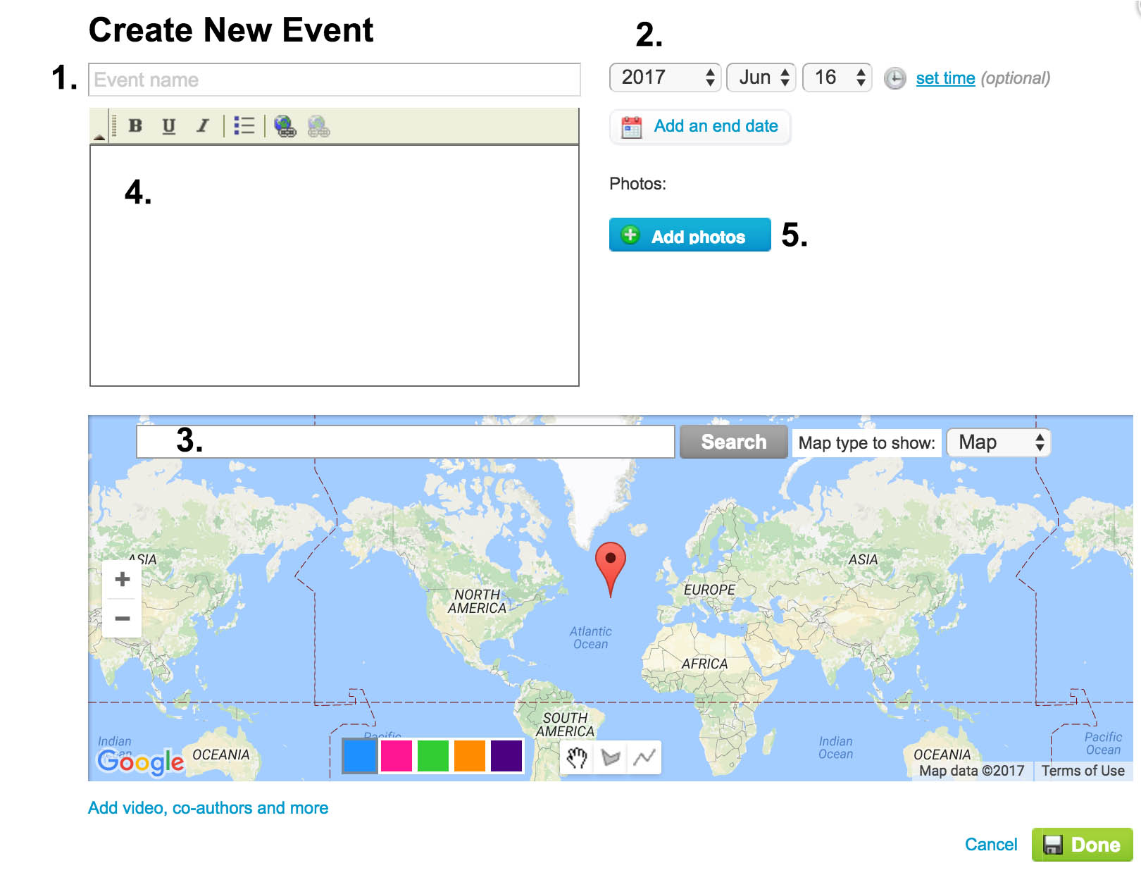

Step Five: Create Story. After creating the individual events for your timeline, on the MyHistro dashboard, click the “Stories” tab, and then the green button for “Create New Story.” Give your story a name, a one-line description, and an iconic photo (can be one of the photos you used in your events). Click “Next” to add events to your story. You will now see a column containing all of the events you have created. Hover your mouse over individual events and click “Add to Story” to add an individual event to your story. When finished click “Save Story” and you will see the completed timeline. If you need to edit your story, go back to the MyHistro dashboard, click the “Stories” tab, and hover your mouse over a given story, and click “Edit.”

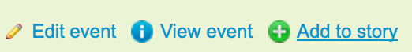

Step Six: Share/Embed. MyHistro provides a number of options for sharing your timeline. We would like you to copy the “Embed story” code found at the bottom of your story page, navigate over to your Weebly portfolio page at weebly.com, drag an “embed code” block into the space below “cultural collections project 2,” then paste your copied embed code from MyHistro into that embed code block. Click “Publish” in Weebly to lock in these changes to your portfolio, then look at czechccr.weebly.com to make sure your timeline is displaying properly on the published site. You will always edit your timeline in MyHistro, but through embed code, people will be able to view your story and your latest updates on your Weebly portfolio page.

